**Group 10 Report 1**

**Successfully Implemented Story Cards:**

Card 1:

Name of Story - Create Typing Game Page

Team Member - Joseph Trembley

Tasks for Card:

i. Page has place for randomly generated words to appear on screen

ii. Page can take user input as text field

iii. Page links to Typing High Scores Page (hyperlink fine for now)

Card 2:

Name of Story - Create Main Menu

Team Member - Ben Meinders

Tasks for Card:

i. Create Button to Typing Game

ii. Create Button to Simon Says

iii. Create Appropriate Titles

Card 3:

Name of Story - Create Simon Says Instruction Page

Team Member - Joao Lira

Tasks for Card:

i. Link to Simon Says Game Page

ii. Link to view Simon Says High Scores

iii. Link back to home page

Card 4:

Name of Story - Create Typing Instruction Page

Team Member - Joao Lira

Tasks for Card:

i. Link to Typing Game Page

ii. Link to View High Scores

iii. Link back to home page

Card 5:

Name of Story - Create Typing High Scores

Team Member - Ben Meinders

Tasks for Card:

i. Page has field for dummy high scores to be entered in

ii. Page links back to main menu

iii. Page links back to Typing game page

Card 6:

Name of Story - Find/Create Extensive Word List

Team Member - Joseph Trembley

Tasks for Card:

i. Figure out reasonable number of words where repetition is uncommon

ii. Find a source to pull words/phrases from

iii. Randomly pull words/phrases from list and display

Card 7:

Name of Story - Create Simon Says High Scores Page

Team Member - Joao Lira

Tasks for Card:

i. Page had field for dummy high scores to be stored in

ii. Page links back to main menu

iii. Page links back to Simon Says game page

Card 8:

Name of Story - Create Simon Says Game Page

Team Member - Sandro Panchame

Tasks for Card:

i. Page has 4 different colored squares that the user can click on

ii. Page has a redirect to the high scores page (hyperlink fine for now)

Card 9:

Name of Story - Generate Random Sequence

Team Member - Sandro Panchame

Tasks for Card:

i. Create javascript code for random numbers (1-4, for the color sequence)

ii. Apply random number generator to a Sequence

iii. Apply the results to an image for testing

**Use-case Diagram of Story Cards:**

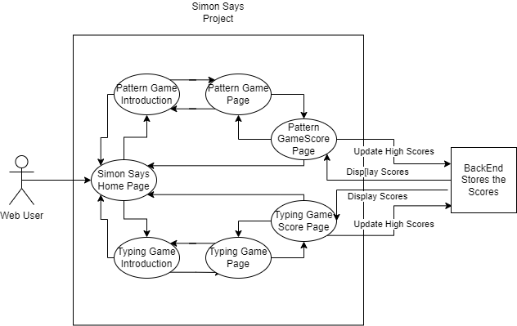

**UI Description with Screenshots:**

Card 1: Create Typing Game Page

This story card is to create the basic UI for the Typing Game Page so that the user sees the game.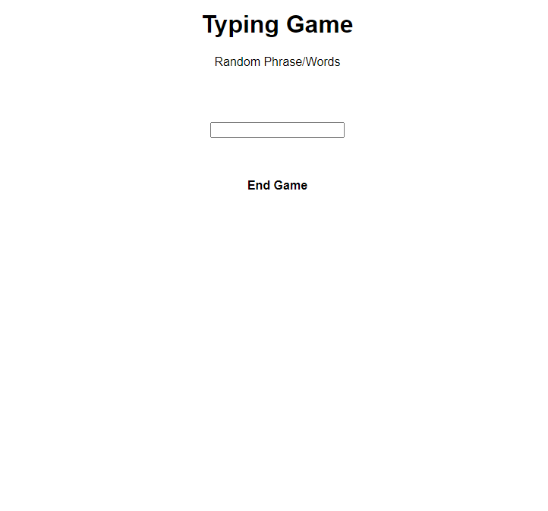

Card 2: Create Main Menu

This story card is to create the homepage so that the user can easily choose between the two game modes.



Card 3: Create Simon Says Instruction Page

This story card is to give the user instructions on how to play the Simon Says game, also called Memorize the Pattern.

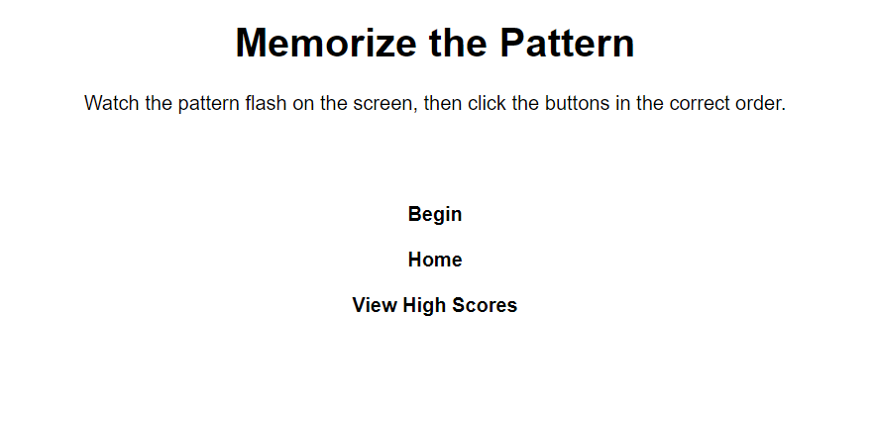

Card 4: Create Typing Instruction Page

This story card is to give the user instructions on how to play the Typing game, called Type the words

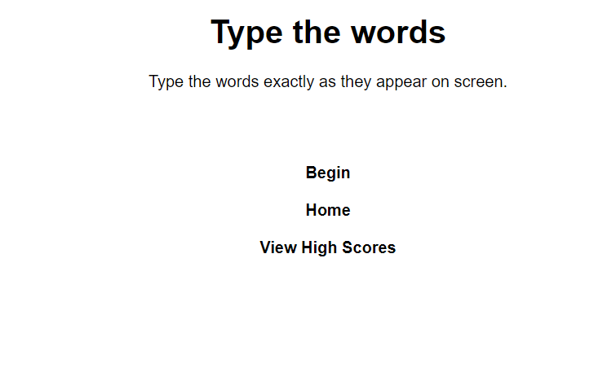

Card 5: Create Typing High Scores

This story card is to show the high scores for the typing game.

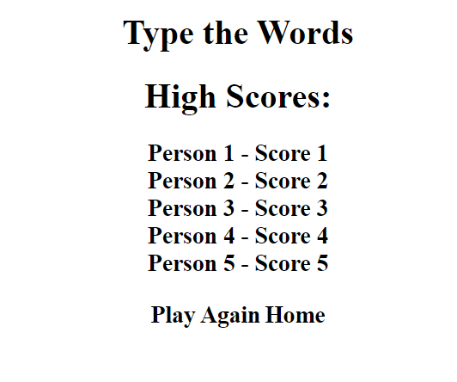

Card 6: Find/Create Extensive Word List

This story card is to find a word list for the backend to use to generate a random word for the Typing game mode.

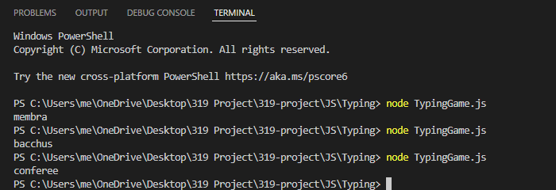

Card 7: Create Simon Says High Scores Page

This story card is to show the high scores for the simon says pattern game.

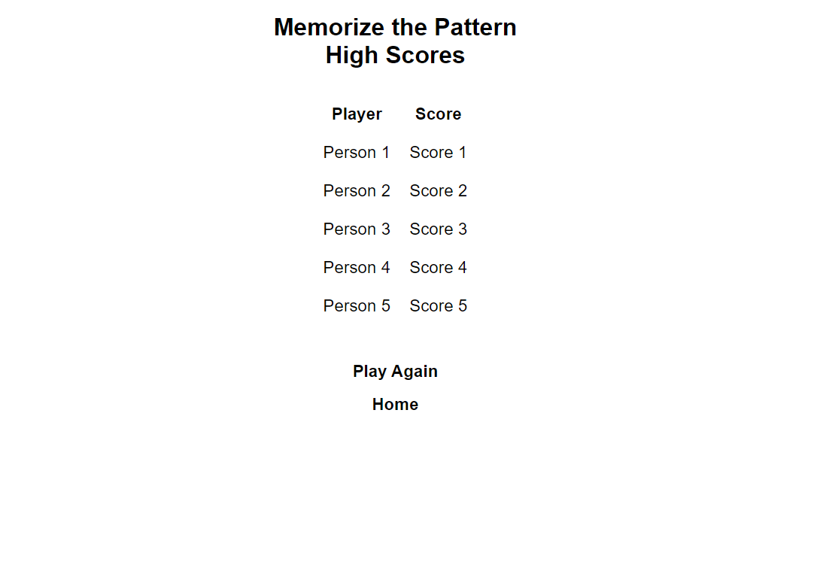

Card 8: Create Simon Says Game Page

This story card is to show the UI for the simon says pattern game.

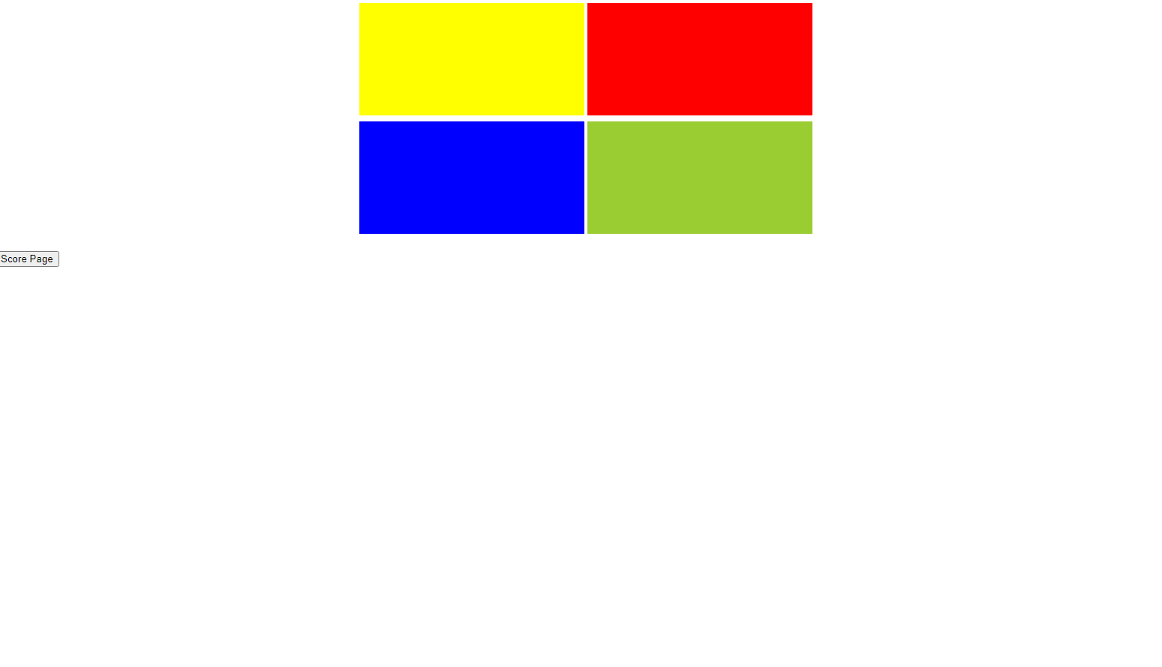

Card 9: Generate Random Sequence

This story card is to create and hold a random sequence for the pattern game.

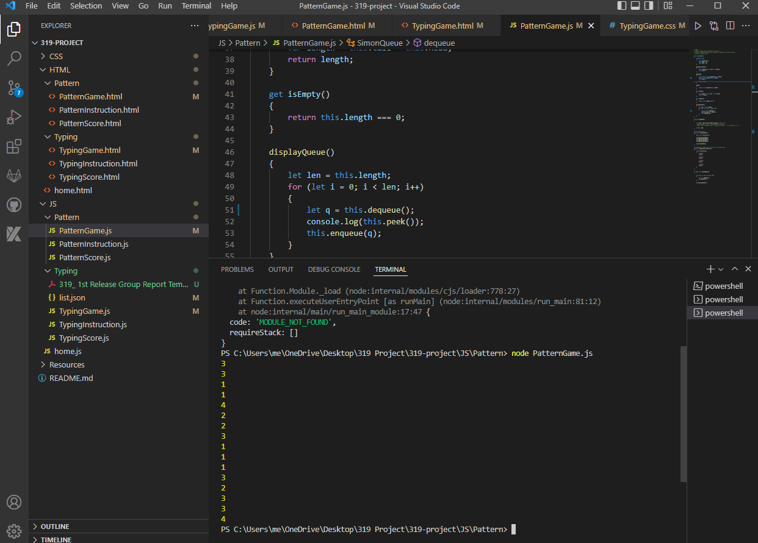

Testing:

No testing applicable at this stage, but we are completing unit/UI tests in the next release.

Plan for 2nd Release:

Card 10: Link Typing Game Page to Javascript

Card 11: Link Simon Says Page to Javascript

Card 12: Save High Scores for Typing Game

Card 13: Save High Scores for Simon Says

Card 14: Selenium/JUnit Tests for Pattern Game

Card 15: Selenium/JUnit Tests for Typing Game